**Name : mayar mahmoud mohamed**

**B.N: 964**

**Date : 5/6/2020**

**Topic:** **Artificial Intelligence**

**Course code: ECE001**

**Github link :**

**Github page :**

**Application brief :**

Artificial Intelligence is considered one of the branches of computer science, and one of the main pillars upon which the technology industry is based in the current era, and the term artificial intelligence can be defined as the ability of digital machines and computers to perform certain tasks that mimic They are similar to those of intelligent beings.

There are three types of artificial Intelligence 1-Narrow Artificial Intelligence (ANI )2- General Artificial Intelligence (AGI) 3- Superior Artificial Intelligence (ASI).And many fields of Al such as 1- Emotion Recognition 2- Speech Recognition 3- Deep learning. And many importance as 1. Improving the collection, processing and dissemination of health data and information can enhance the diagnosis and treatment of patients. And some problems as 1- An increase in the difference in income between the rich and the poor 2-Loss of jobs Much of the functionality will be replaced by an AI client that does the same tasks that humans do

**Screenshots :**

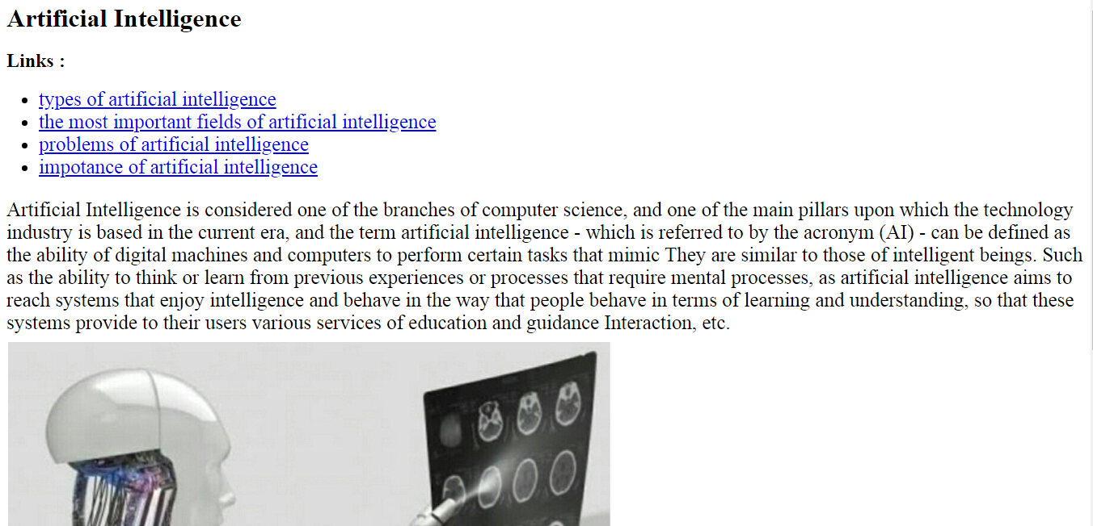

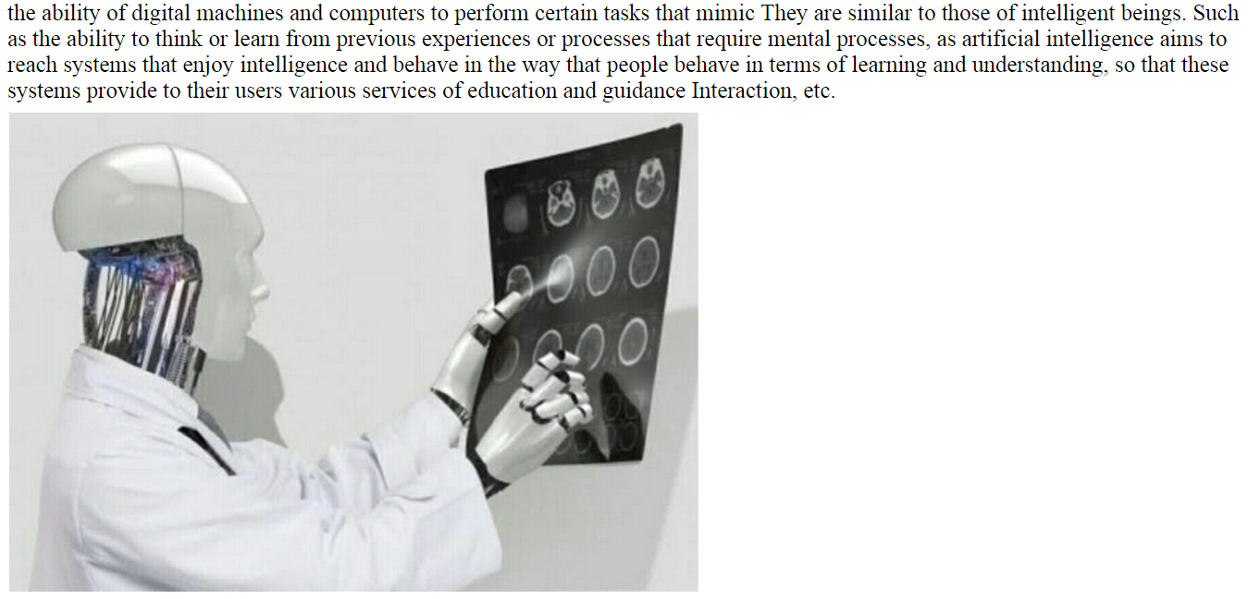

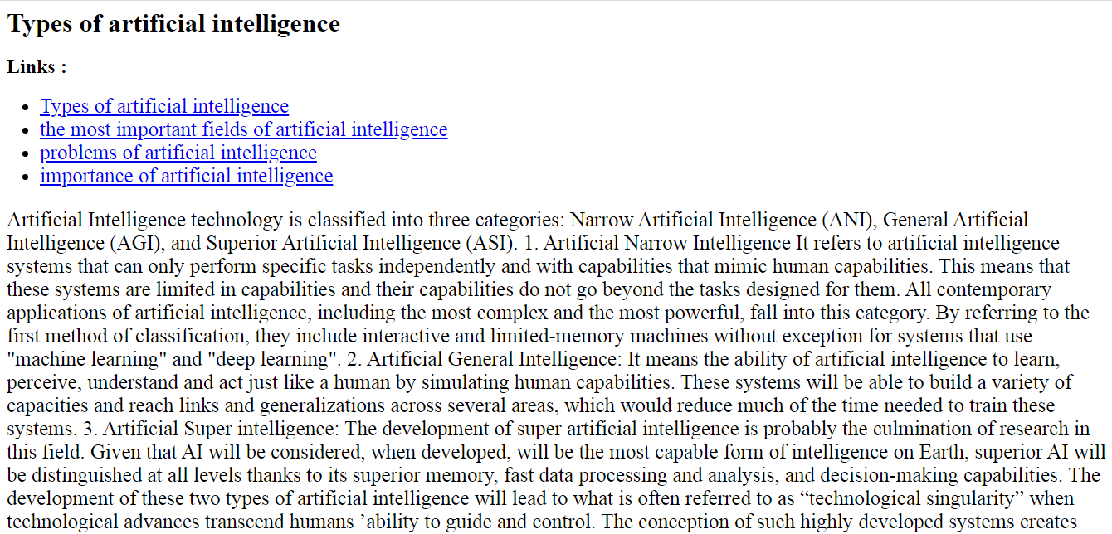

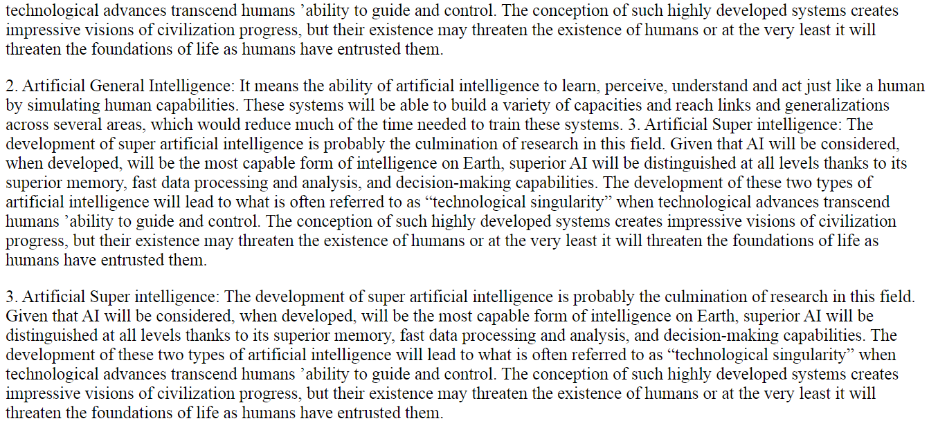

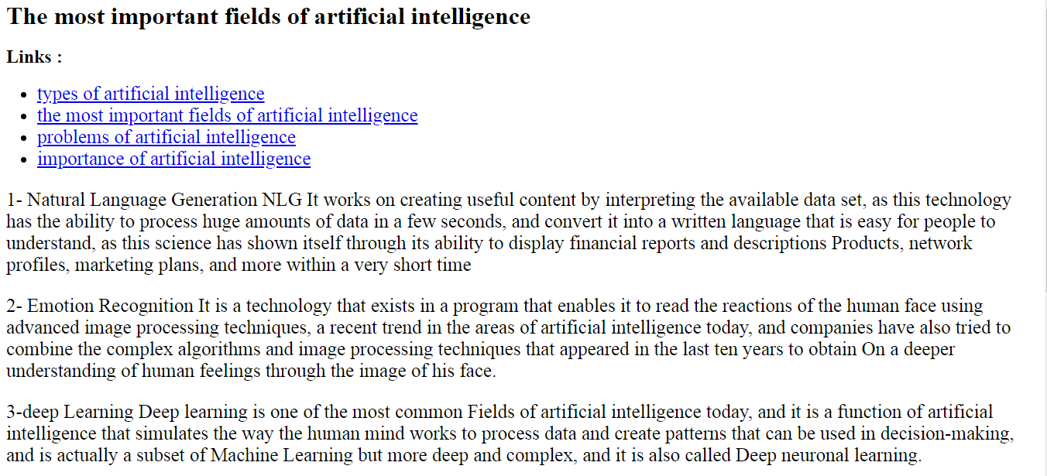

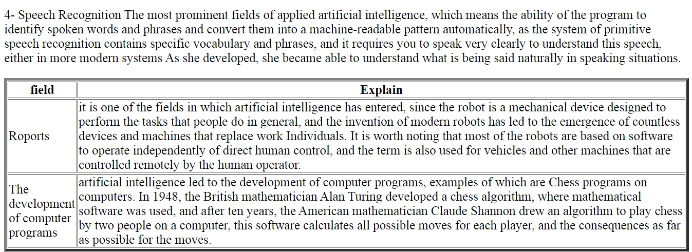

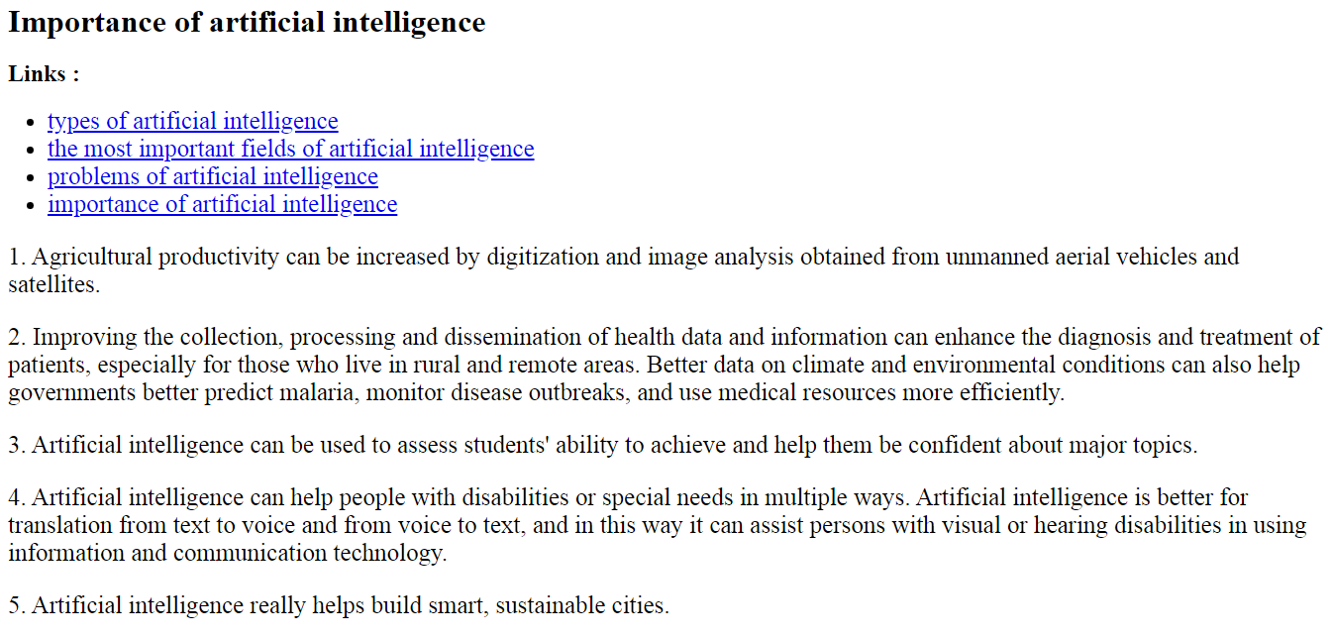

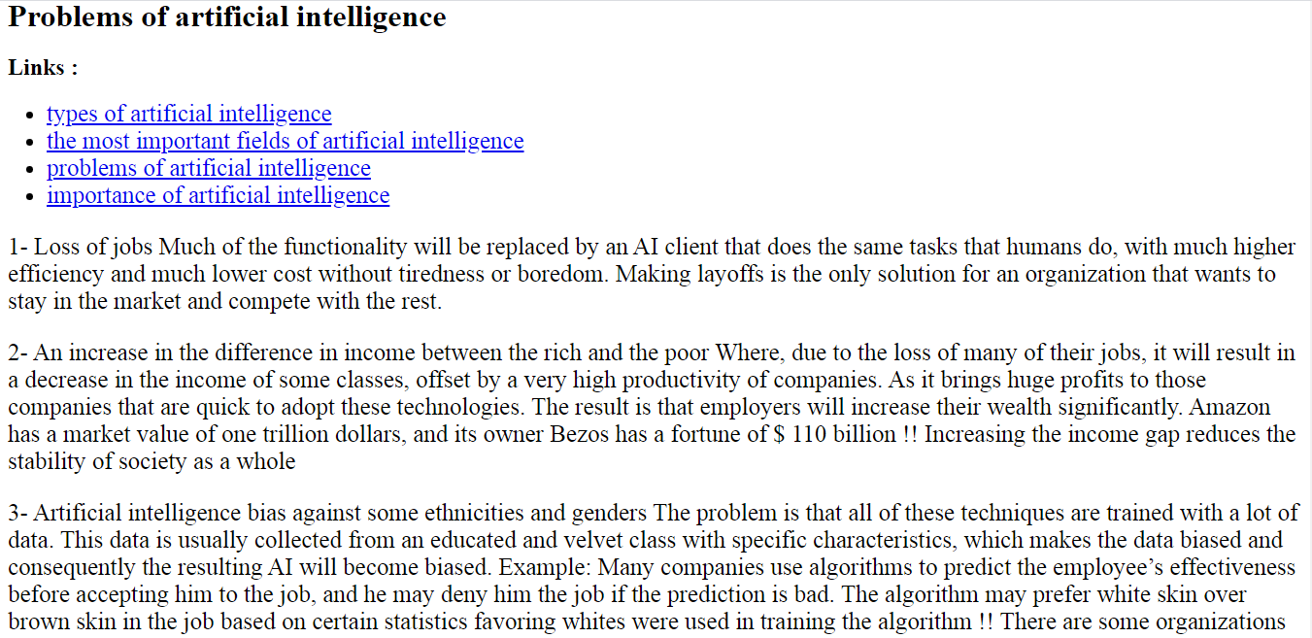

**Source code :**

